- Do not edit/delete any heading or section with red text.
- Type /paste you answers in relevant sections (below Final Answer (in all questions , Approach (wherever required ) and Charts & tables (wherever required)) of the solution
- Link to submission guidelines
- Please note that submission not following the guidelines will not be accepted

OBJECTIVE QUESTIONS

Question 1: What is the total no. of tables present in the data?

Solution:

Final Answer (if any):2

Approach (if any):
There are 2 tables are available in the given sheet Row data & Country description.
Charts & Tables (if any):
- Table / Chart Name:
<Name of the table or chart used>
- Description:
<What the table or chart represents>

Question 2: What is the total no. of attributes present in the data?

Solution:

Final Answer (if any):20

Approach (if any):
The original Raw Data table contains 20 attributes/columns from A:T. The Country Name column is a lookup/helper field and should not be counted as an original Raw Data attribute.
=COUNTA('Raw Data'!A1:T1)

Charts & Tables (if any):
- Table / Chart Name:
<Name of the table or chart used>
- Description:
<What the table or chart represents>

Question 3: How many categorical columns are there in the data? [Search about categorical and continuous data, and try to answer this question]

Solution:

Final Answer (if any):14

Approach (if any):
The columns contain discrete values or labels Those we can consider categorical columns and the columns that contain numerical value with range are considered as continuous columns So according to that, I had Extracted the category column as follows-
1 CountryCode, 2 RestaurantName, 3 City, 4 Address, 5 Locality,
6 LocalityVerbose, 7 Cuisines, 8 Currency, 9 Has_Table_booking,
10 Has_Online_delivery, 11 Is_delivering_now, 12 Switch_to_order_menu,
13 Price_range, 14 Country Name

Charts & Tables (if any):
- Table / Chart Name:
<Name of the table or chart used>
- Description:
<What the table or chart represents>

Question 4: The data consists of some inconsistent and missing values so ensure that the data used for further analysis is cleaned.

Solution:

Final Answer (if any):

Approach (if any):
The dataset contained some blank rows and missing values. Before proceeding with the analysis, I cleaned the dataset by identifying and deleting the blank rows.
Removing these completely blank rows ensured that they did not affect the pivot tables, calculations, or visualizations used for further analysis. I retained all rows containing valid data.

Charts & Tables (if any):
- Table / Chart Name:
<Name of the table or chart used>
- Description:
<What the table or chart represents>

Question 5: Using the LookUp functions, fill up the countries in the original data using the country code.

Solution:

Final Answer (if any):
Country names were populated in Cleaned Data – Column D using VLOOKUP.
Approach (if any):
=VLOOKUP(C2,'country description'!$A$2:$B$16,2,0)

Charts & Tables (if any):
- Table / Chart Name:
<Name of the table or chart used>
- Description:
<What the table or chart represents>

Question 6: Create a table to represent the number of restaurants opened in each country.

Solution:

Final Answer (if any):
India has the highest number of restaurants with 8,652, followed by the United States with 425.

Approach (if any):
Created a PivotTable with:
- Rows: Country Name
- Values: Count of RestaurantID

Charts & Tables (if any):
- Table / Chart Name:Number of Restaurants Opened in Each Country

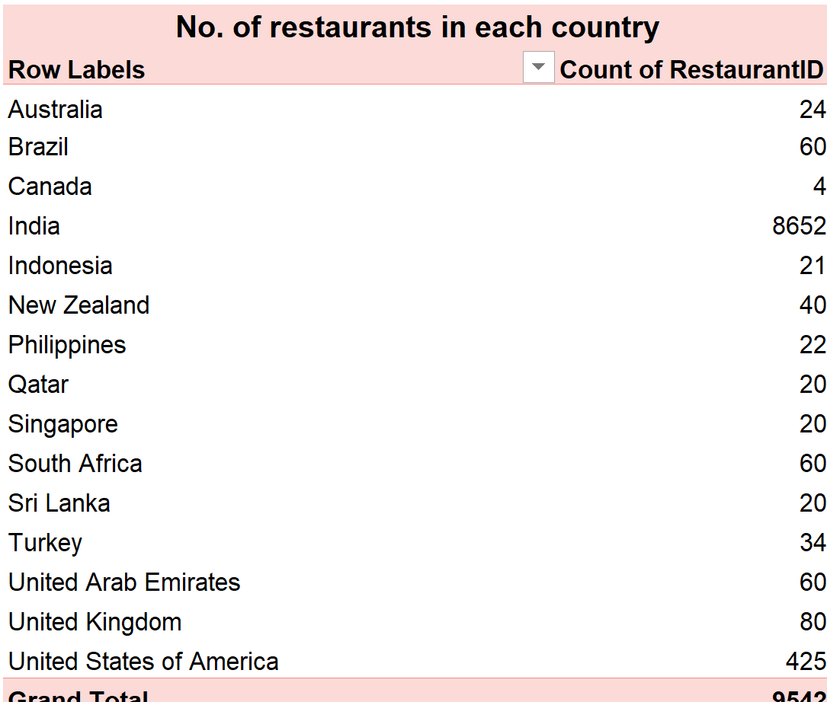

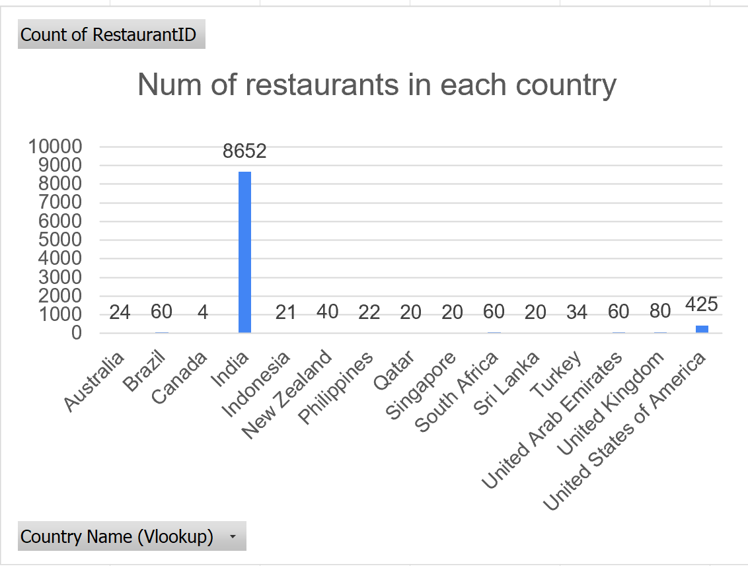
Name of the table: Number of Restaurants Opened in Each Country
Description: Shows the total number of restaurants in each country based on the count of Restaurant IDs.
Name of the chart: Num of restaurants in each country
Description: A column chart comparing the number of restaurants opened across different countries. India has the highest number of restaurants, followed by the United States of America.

Question 7: Also, the management wants to look at the number of restaurants opened each year, so provide them with something here.

Solution:

Final Answer (if any):

Approach (if any):
Used the formula =LEFT(T2,4) in Column AA to extract the first four digits (year) from the opening-date data in Column T.
Named Column AA as Year of Opening.
Pulled RestaurantID into Column A.
Created a PivotTable using Year of Opening as the Rows field and RestaurantID as the Values field.
Used Count of RestaurantID to calculate the number of restaurants opened in each year.
Created a column chart based on the PivotTable to visualize the yearly restaurant openings.

Charts & Tables (if any):

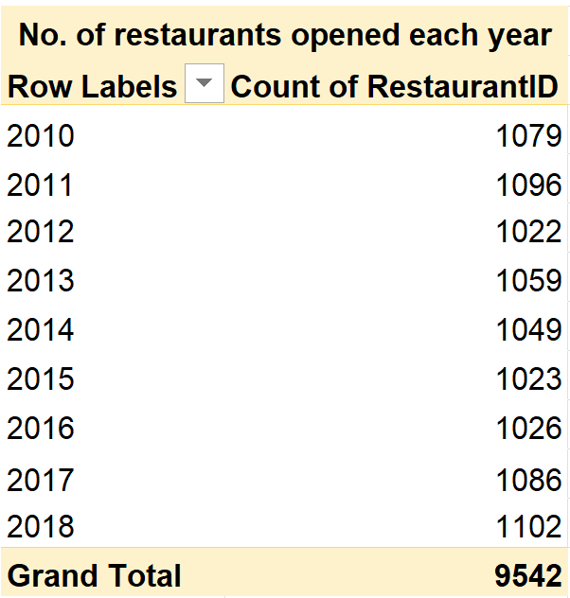

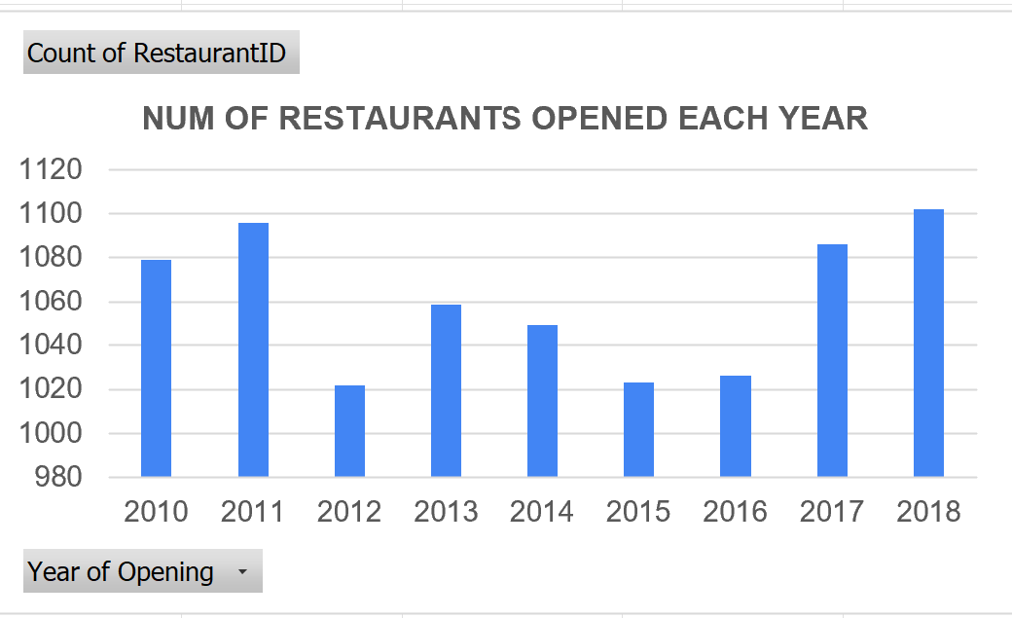

- Table / Chart Name
:Number of Restaurants Opened Each Year

- Description:
Represents the total number of restaurants opened from 2010 to 2018, showing the yearly trend in restaurant openings.

Question 8: What is the total number of restaurants in India in the price range of 4?

Solution:

Final Answer (if any): 388

Approach (if any):
=COUNTIFS('Cleaned Data'!C:C,"1",'Cleaned Data'!Q:Q,"4")
Country Code 1 represents India and Price Range 4 identifies the highest price category.

Charts & Tables (if any):
- Table / Chart Name:
<Name of the table or chart used>
- Description:
<What the table or chart represents>

Question 9: What is the average number of voters for the restaurants in each country according to the data?

Solution:

Final Answer (if any):
Indonesia has the highest average votes per restaurant at 772.10, followed by the UAE at 493.52 and Turkey at 431.47.

Approach (if any):
Created a PivotTable with:
- Rows → Country Name
- Values → Votes
- Value calculation → Average

Charts & Tables (if any):
Table / Chart Name: Average Votes by Country

Description: Represents the average number of votes received by restaurants in each country, allowing comparison of customer engagement across countries

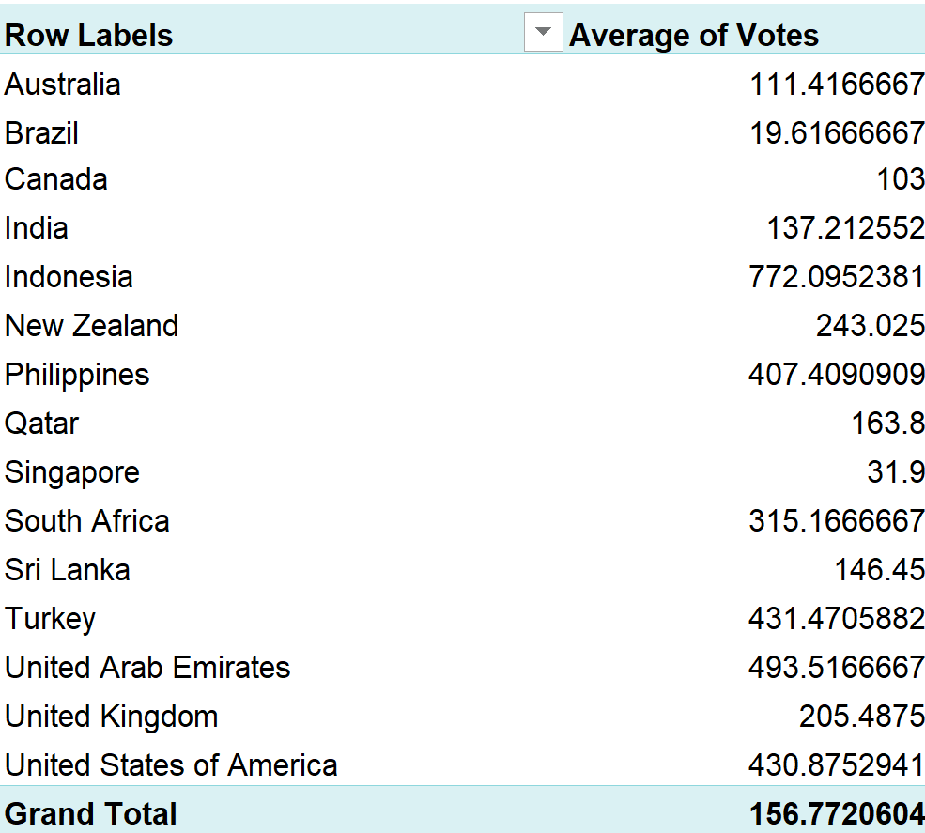

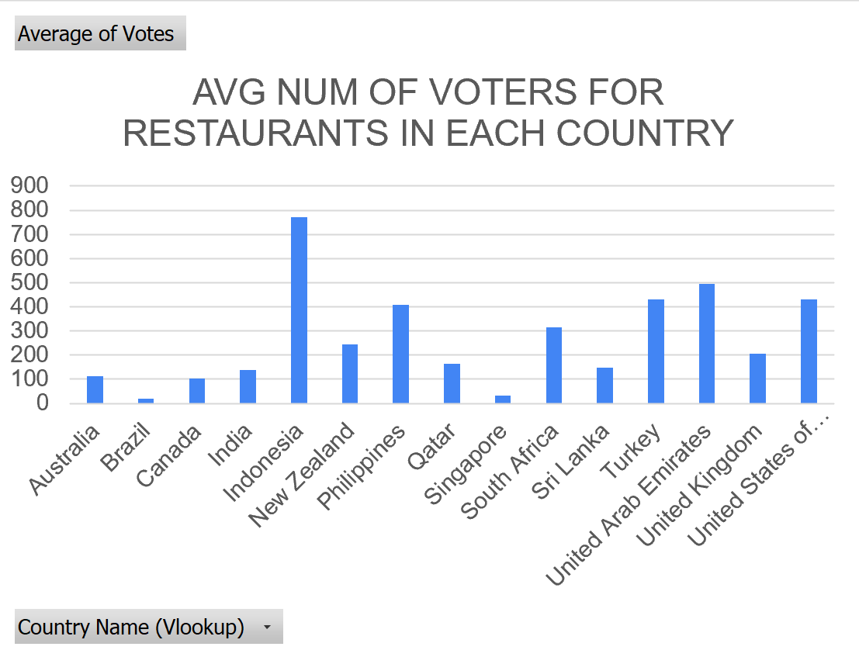

Question 10: Calculate the average rating for all the restaurants that have price_range < 4 and provide online delivery. Use only the “IF” function, Logical Operators, and Aggregation functions to solve this problem. [Note: Don’t use Conditional aggregation in this question.]

Solution:

Final Answer (if any):
3.27381151

Approach (if any):
=AVERAGEIFS('Cleaned Data'!T:T,'Cleaned Data'!Q:Q,"<4",'Cleaned Data'!N:N,"Yes")

Charts & Tables (if any):
- Table / Chart Name:
<Name of the table or chart used>
- Description:
<What the table or chart represents>

Question 11: Using Conditional formatting highlight the rows of restaurants that are located in the countries or cities that you’ve suggested to the management for opening new restaurants.

Solution:

Final Answer (if any):
Indonesia, Philippines, Qatar
Approach (if any):
On the basis of data provided, the higher rating shows the customer satisfaction & less restaurant count shows more opportunity for expansion

Charts & Tables (if any):
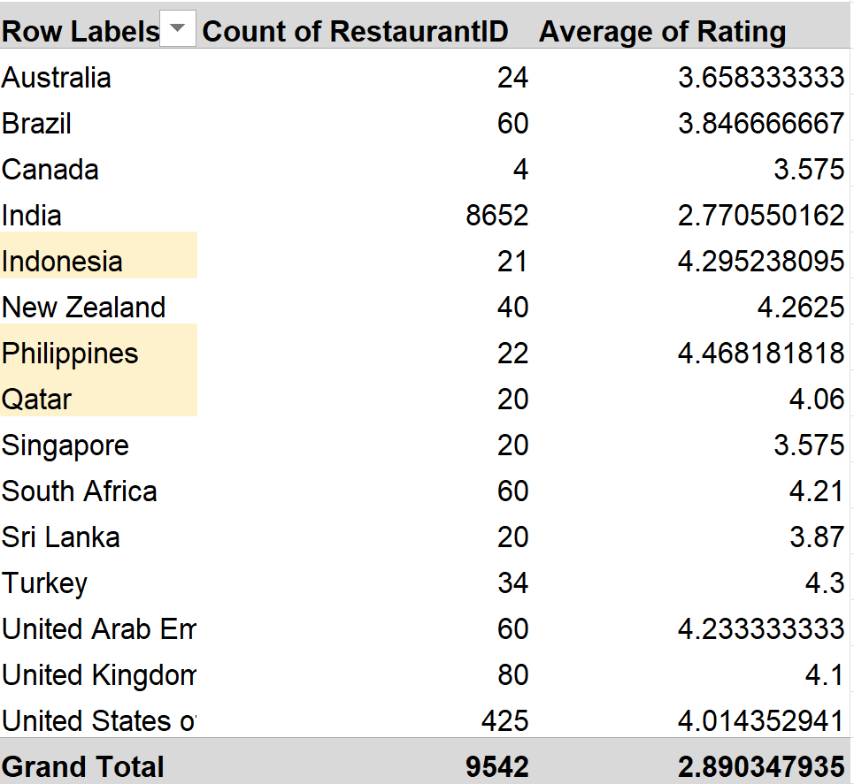
- Table / Chart Name:
Country-wise Restaurant Competition and Rating Analysis

- Description:
This table compares the number of restaurants and their average ratings across countries to identify markets with lower competition and higher customer satisfaction.

Question 12: Create a new customized price column that consists of the abbreviation/symbol of the currency along with the Average_cost_for_two value. [Use string operations to do this task]

Solution:

Final Answer (if any):
Done in cleaned data sheet in column V

Approach (if any):
=MID(L2,FIND("(",L2)+1,FIND(")",L2)-FIND("(",L2)-1)&S2
This extracts the currency abbreviation/symbol and combines it with Average Cost for Two.

Charts & Tables (if any):
- Table / Chart Name:
<Name of the table or chart used>
- Description:
<What the table or chart represents>

Question 13: How can you create an array formula in Excel or Google Sheets to count the number of restaurants listed that do not offer online delivery, are in the lowest price range, and have an average cost for two people less than or equal to 250 Indian Rupees?

Solution:

Final Answer (if any):
1,308

Approach (if any):
=IF(AND(N2="No",Q2=1,AA2<=250),1,0)
In cleaned data sheet Z2

=SUM(Z2:Z9543)
In Q13. Objective sheet
Charts & Tables (if any):
- Table / Chart Name:
<Name of the table or chart used>
- Description:
<What the table or chart represents>

SUBJECTIVE QUESTIONS

Question 1: Suggest a few countries where the team can open newer restaurants with lesser competition. Which visualization/technique will you use here to justify the suggestions?

Solution:

Approach:
Least count of restaurant Shows the higher opportunity and lesser competition.
also we will sort the data from Higher to lower rating, which will gone show us satisfaction of the customer. To do this I took countries, restaurants ids and average rating in rows and applied conditional formatting where count of restaurants must be less than 25 and average rating must be more than 4. Therefore, as result we got Indonesia, philippines and Qatar highlighted representing countries with lesser competition to open new restaurants.

Charts & Tables:

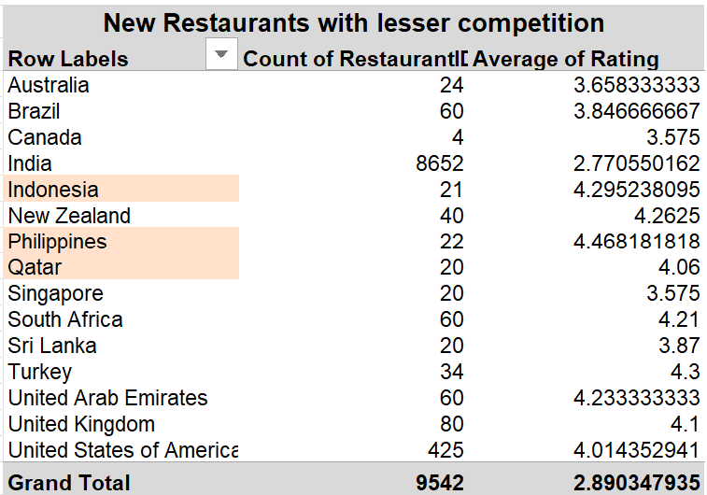

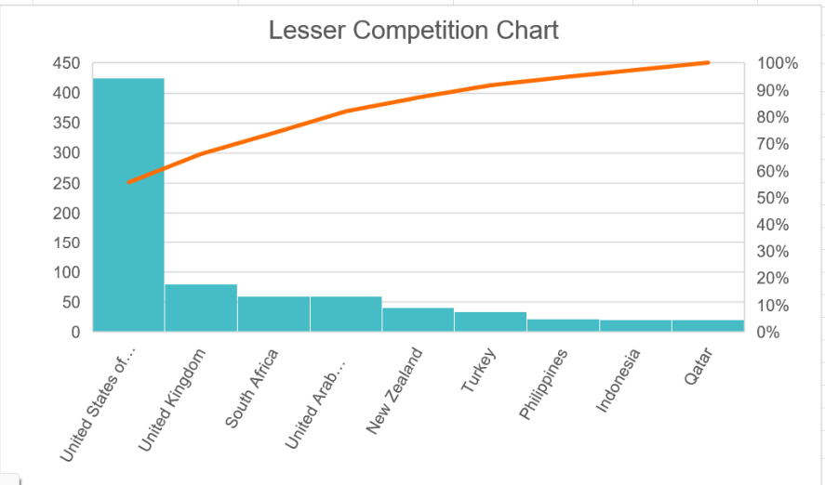
- Table / Chart Name:
New Restaurants with Lesser Competition – Country Analysis

- Description:
Here we can clearly see that Philippines, Indonesia and Qatar is the country having least restaurants which shows least competition and also, the rating line shows the customer are satisfied in that country with the restaurants That means there are higher probability for profitable restaurant opening in least competition.

Insights:
• Philippines: 22 restaurants, rating 4.47
• Indonesia: 21 restaurants, rating 4.30
• Qatar: 20 restaurants, rating 4.06

Recommendations:
Prioritize the Philippines, followed by Indonesia and Qatar, for potential expansion.

Question 2: Come up with the names of States and cities in the suggested countries suitable for opening restaurants.

Solution:

Approach:
I analysed restaurant ratings and competition levels in the Philippines, Indonesia, and Qatar to identify the cities with the highest customer satisfaction. The goal was to find the most suitable cities for new restaurant openings based on ratings. To do this I created three pivot tables with countries, count of restaurants and average rating in rows and country as filter to each table. I applied conditional formatting in each pivot table highlighting higher ranges in green, mid ranges in yellow and low ranges in red.

Charts & Tables:
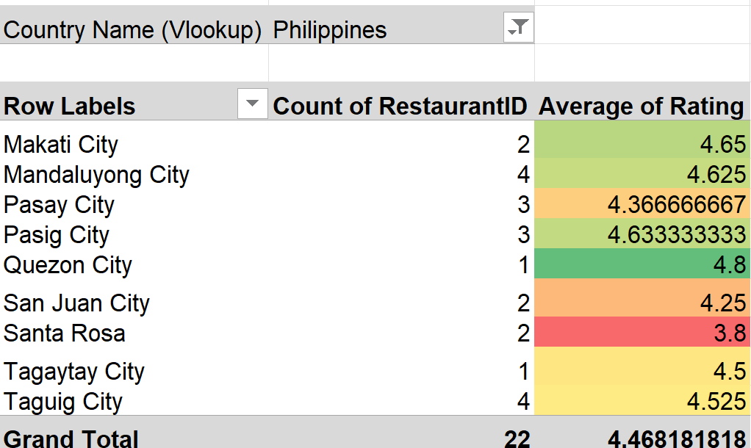

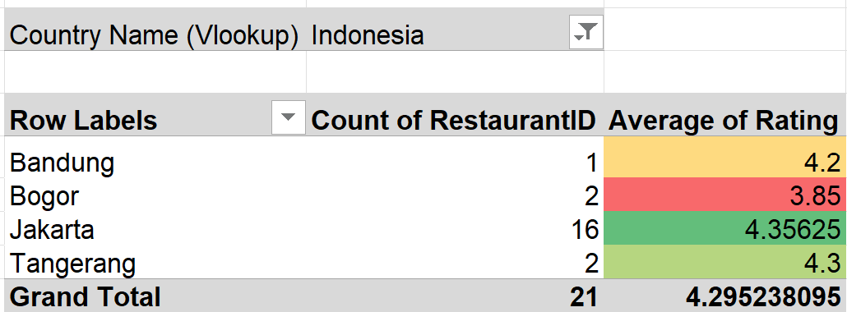

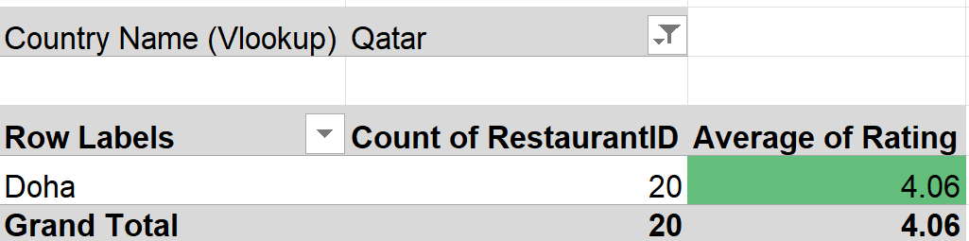
- Table / Chart Name:
Cities in Suggested Countries – Competition & Rating Analysis

- Description:
The table shows:Cities are filtered from the recommended countries.Count of RestaurantID measures the existing level of competition and Average Rating measures customer satisfaction. Conditional formatting is used on the Average Rating column to quickly identify cities with stronger ratings.

Insights:
Quezon City has a rating of 4.8, Jakarta 4.36, and Doha 4.06.
Recommendations:
Prioritize Quezon City, Jakarta and Doha for further market evaluation.

Question 3: According to the countries you suggested, what is the current quality regarding ratings for restaurants that are open there?

Solution:

Approach:
I checked the average ratings of existing restaurants in the Philippines, Indonesia, and Qatar to understand their quality. This helps to evaluate customer satisfaction in these regions

Charts & Tables:
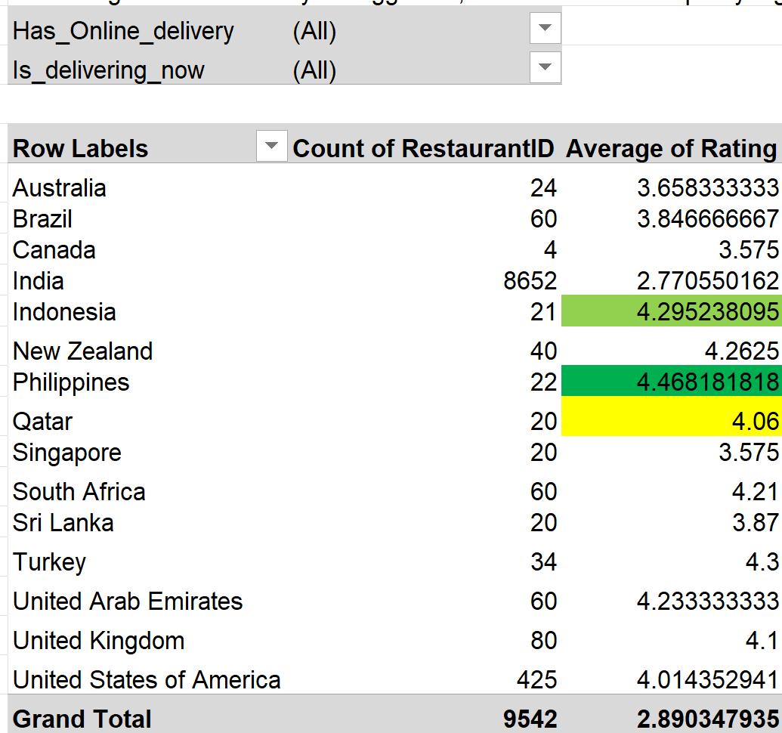

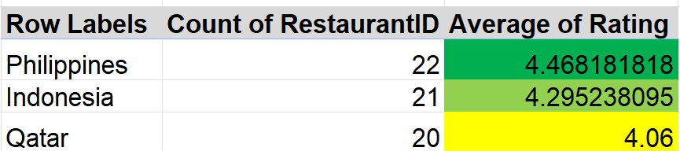

- Table / Chart Name:
Restaurant Quality by Suggested Countries

- Description:
The table compares the number of restaurants and their average ratings in Indonesia, Philippines, and Qatar.

Insights:
The Philippines has the highest rating of 4.4,6 showing excellent satisfaction. Indonesia's 4.29 is also impressive, and Qatar's 4.06 reflects a positive reception, although slightly lower.

Recommendations:
Given high customer satisfaction, the Philippines, Indonesia, and Qatar are promising for new restaurants. The Philippines leads in potential, followed closely by Indonesia, while Qatar offers solid opportunities.

Question 4: Also, what is the current expenditure on food in the suggested countries, so we can keep our financial expenditure in control?

Solution:

Approach:
I reviewed the average cost for two in Indonesia, the Philippines, and Qatar to assess food expenditure. This helps guide financial planning and control initial investments in these countries.

Charts & Tables:

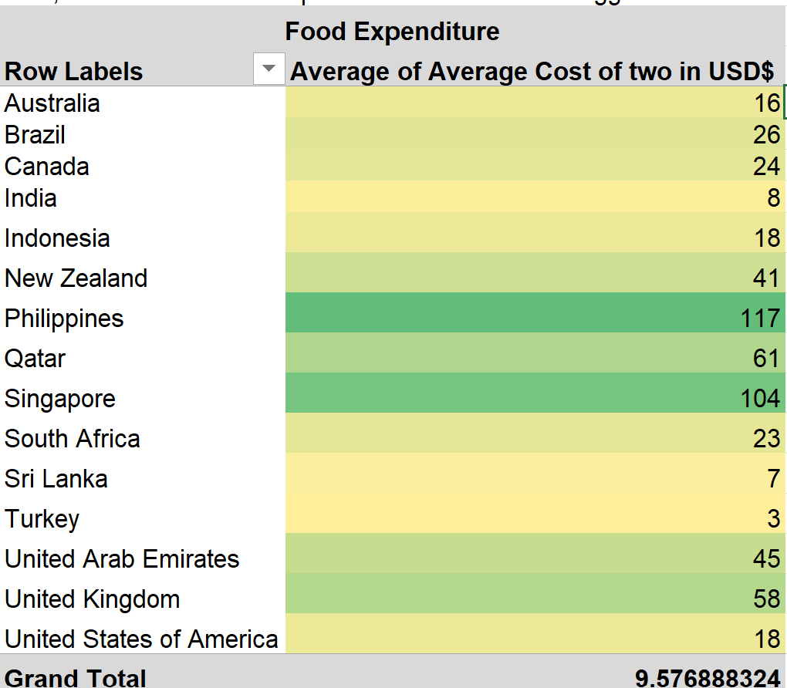

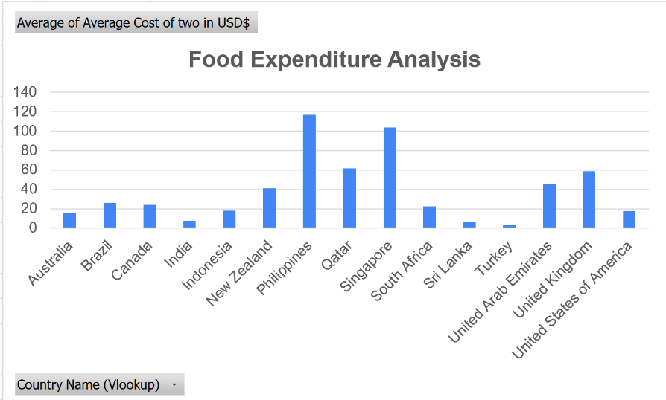
- Table / Chart Name:
Food Expenditure of Suggested Countries
- Description:
The table compares the average cost of food for two people across the three shortlisted countries.

Insights:
Indonesia has the lowest average cost for two at $18, followed by Qatar at $61. The Philippines has the highest cost, with an average of $117 for two, indicating higher expenses.

Recommendations: To minimize initial investment, it’s advisable to prioritize opening in Indonesia and Qatar, where costs are lower. The Philippines may be considered later due to its higher expenses.
Row Labels | Average cost for two IN USD ($)
Indonesia | 18
Philippines | 117
Qatar | 61
Total expenditure | 196

Question 5: Come up with the names of restaurants from the recommended states that are our biggest competitors and also those that are rated in the lower brackets, i.e. 1-2 or 2-3.

Solution:

Approach:
I analysed the average ratings of low-performing restaurants in the recommended countries (Qatar, Philippines, and Indonesia). This helps identify potential competitors with lower customer satisfaction in these regions.

Charts & Tables:

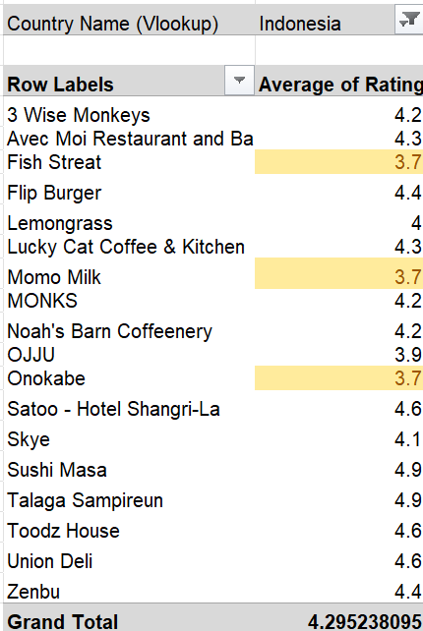

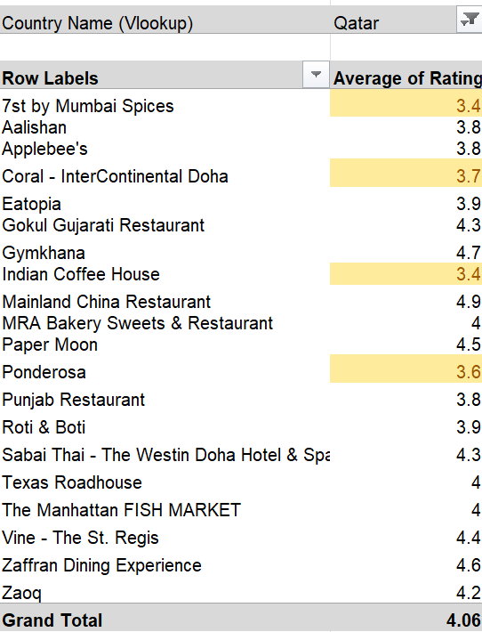

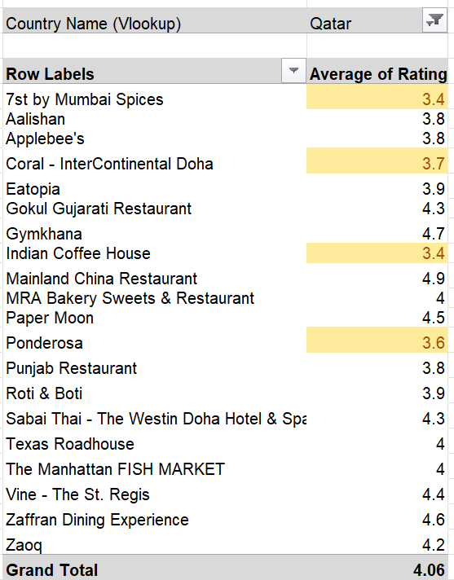

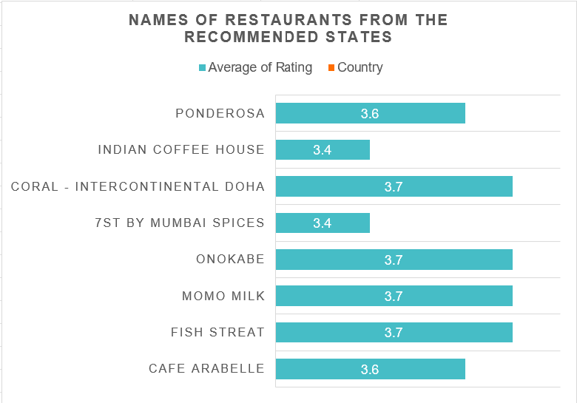

- Table / Chart Name:
Competitor Restaurants from Recommended States

- Description:
The table lists restaurants from the recommended locations along with their average ratings, highlighting lower-rated competitors.

Insights:
Most restaurants shown have ratings between 3.4 and 3.7, indicating moderate performance. 7st by Mumbai Spices and Fish Streat have the lowest rating at 3.4. Indian Coffee House also has a rating of 3.4. Cafe Arabelle and Ponderosa have ratings of 3.6. The selected restaurants have an overall average rating of 3.56, leaving room for a new restaurant to compete through better quality and service.

Recommendations:
These restaurants, with their lower ratings, represent opportunities to outperform competitors by offering better service and quality. Focus on improving customer satisfaction to gain an edge in these markets.

Question 6: Which cuisines should we focus on in the newer restaurants to get better feedback? Does the choice of cuisines affect the restaurant ratings?

Solution:

Approach:
I reviewed the top-rated cuisines in the Philippines, Indonesia, and Qatar to understand which cuisines lead to higher customer satisfaction. This analysis will help in choosing the best cuisines for our new restaurants.

Charts & Tables:
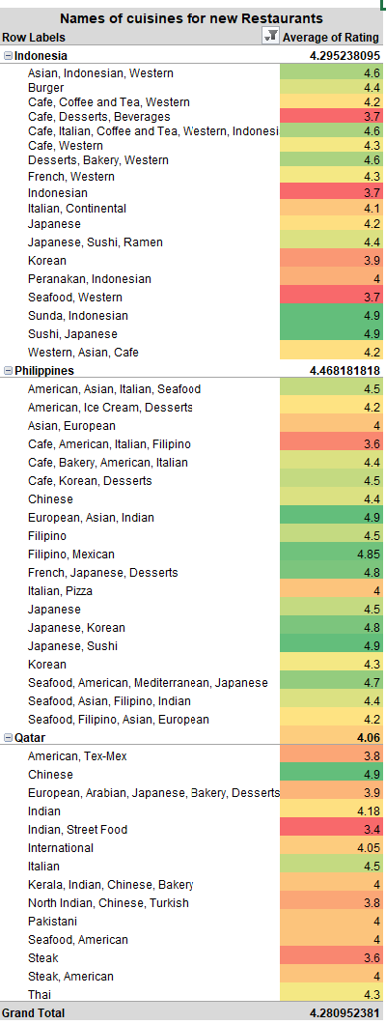

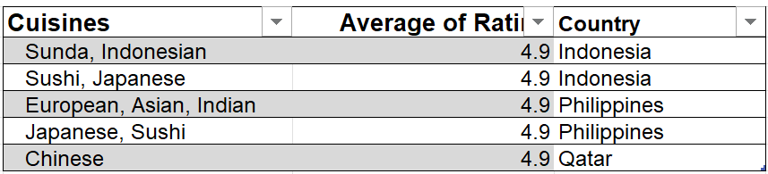

- Table / Chart Name:
Cuisine-wise Restaurant Ratings in Suggested Countries

- Description:
The table compares different cuisines with their average restaurant ratings across Indonesia, Philippines, and Qatar. The bar chart provides a visual comparison of cuisine ratings.

Insights:
The top-rated cuisines in the Philippines include European, Asian, Indian, and Filipino, Mexican all rated 4.9. In Indonesia and Qatar, Sunda, Indonesian, and Sushi, Japanese also hold a perfect 4.9 rating, reflecting their popularity.

Recommendations:
Focusing on Sushi, Japanese, and Sunda cuisines in Indonesia and Qatar, along with European, Asian, and Indian in the Philippines, is likely to yield better feedback and customer satisfaction, boosting overall ratings

Question 7: According to our current data, should we go for online delivery and table booking? Does that affect the customer’s ratings?

Solution:

Approach:
Compare the average ratings of restaurants with and without online delivery and table booking to identify their impact on customer satisfaction.

Charts & Tables:
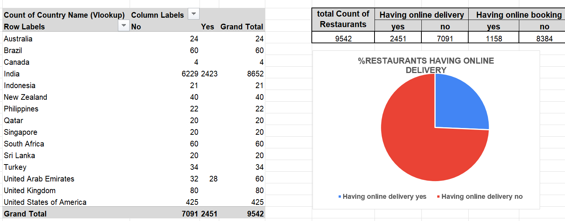

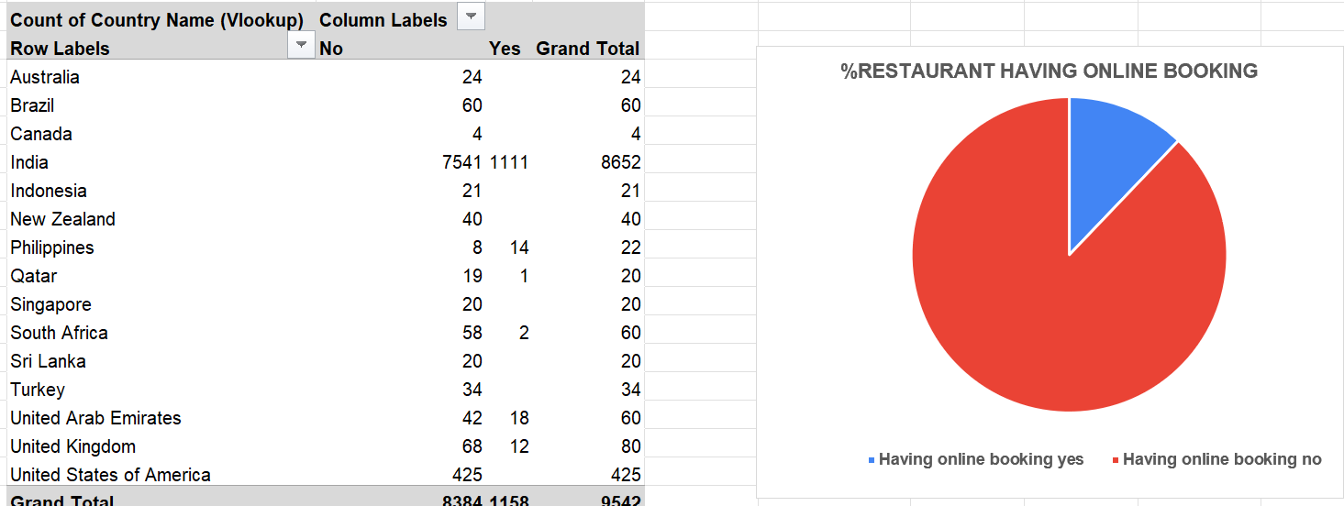

- Table / Chart Name:
Online Delivery and Table Booking Analysis

- Description:
Shows the average ratings based on the availability of online delivery and table booking.

Insights:
Restaurants with table booking have a higher overall rating (3.48) than those without (2.81). Restaurants with online delivery also show a higher average rating (3.29) compared with those without (2.75)

Recommendations:
Yes, offer both online delivery and table booking, as the data suggests both services are associated with higher customer ratings.

Question 8: Should the team keep the rate of cuisines higher? Will that affect the feedback? According to our data are the rates of cuisines and ratings, correlated?

Solution:

Approach:
I analysed the relationship between restaurant ratings and the cost of meals for two. The data was sorted from higher to lower ratings, examining whether higher-rated restaurants also charge more, and I calculated the correlation between price and rating. Correlation = 0.793954

Charts & Tables:
- Table / Chart Name:
Use the actual Excel sheet/chart name, e.g. Cost vs Rating Correlation Analysis.

- Description:
Shows the relationship between average cost for two and restaurant ratings.
Insight:

Insights:
The data shows a moderate correlation (0.793954272620959) between ratings and cost, indicating that restaurants with higher ratings generally charge more. Customers appear satisfied with the quality of the cuisine despite the higher prices, suggesting that price doesn’t negatively impact feedback

Recommendations:
Since customers are willing to pay higher prices for better-rated cuisines, it’s reasonable to keep the rates of dishes at a premium. This strategy should not adversely affect customer satisfaction, as long as the quality remains high.

Question 9: What is the distribution of the number of restaurants of different price ranges in all the countries?

Solution:

Approach:
I reviewed the distribution of restaurants in different price ranges across various countries. The goal was to understand where most lower-priced restaurants are located and identify opportunities for growth in mid-range markets globally.

Charts & Tables:
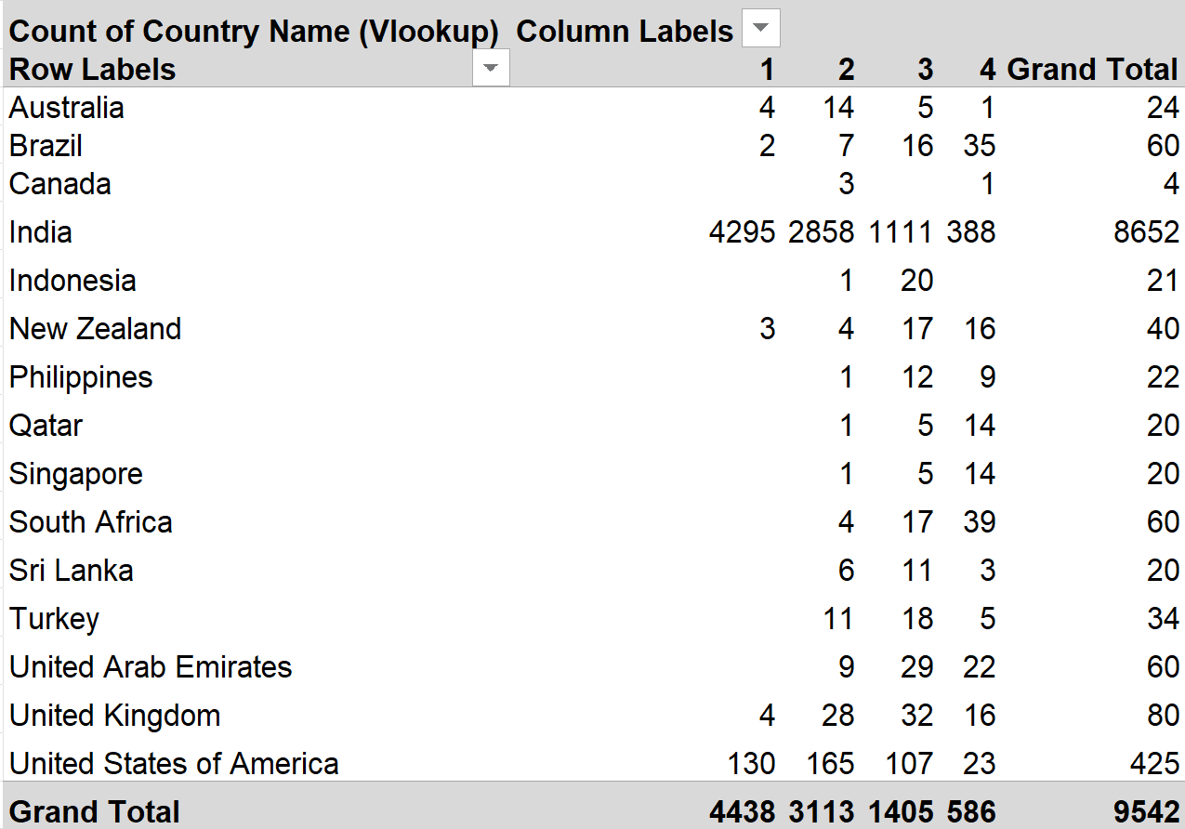

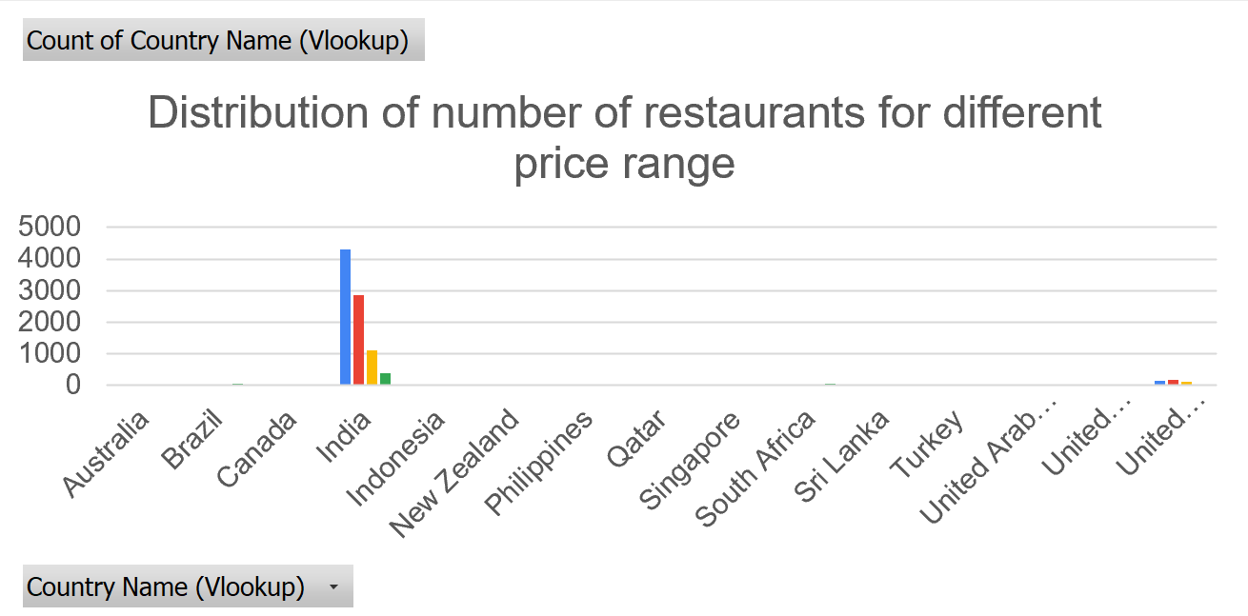

- Table / Chart Name:
Distribution of Restaurants by Price Range in All Countries

- Description:
The table shows the number of restaurants in each country across Price Range 1, 2, 3, and 4.
Insights:
India has the largest number of low-priced restaurants, with 4,295 in the lowest price range. The United States also has a strong presence with 136 low-cost options. Meanwhile, countries like Indonesia, Philippines, Qatar, and Canada have more mid-range restaurants, indicating untapped potential in those regions.

Recommendations:
Focus expansion efforts on India and the USA, where demand is strong but competition is high. To avoid oversaturation, also explore mid-range markets in Indonesia, Philippines, Qatar, and Canada, where there is room for growth and less intense competition.

Question 10: Explain your approach in brief for suggesting countries/cities in order to open new restaurants, if the objective and subjective questions would have not been given to assist you. [you have to give bullet pointers in order to answer this question]

Solution:

Approach:
If objective and subjective questions were not provided, my approach to suggesting countries/cities for new restaurant openings could as follow.
- Data reading, understanding key parameter: - As the data comes for any sort of data analysis. First, we have to read and need to understand what are the key parameters, that are affecting the business. Which is directly reflecting into the given data. It will depend on type of business to business.
- As in business analyst we know the business works on 3 key parameters. which is product, service and customer satisfaction. So we need to find out which are those parameters.
- Then we need a strong strategy as per the available data to get Insights. In our Case
  - Strategy 1:-Higher rating was indicating Those restaurant / city / Country where the customer was satisfied with the product.
  - Strategy 2:-A lower restaurant count shows higher opportunity and less competition. & Number of votes was also indicating the market demand.
  - which will helping to prioritize markets with the most positive feedback for opening new restaurants.
- In the last we have to cheque the cost and expenditure data to ensure the financial feasibility of the new restaurant openings for financial planning.

Charts & Tables:
- Table / Chart Name:
<Name of the table or chart used (should align with Excel subsheet names) along with the screenshot of chart or table>
- Description:
<What the table or chart represents>

Insights:
<Key observations derived from the data>

Recommendations:
<Actionable recommendations based on the insights>

